Multi-Agent System Using Langchain

Multi-Agent Research Assistant a fully autonomous AI system that thinks, searches, reads and writes on its own. Instead of a single AI answering your question from tools, we are deploying a team of specialized intelligent agents that collaborate together to produce a professional research report on any topic you give them. The Search Agent goes out on the live internet and finds the most relevant and recent sources. The Reader Agent then dives deep into those sources, scraping and extracting meaningful content. The Writer Agent takes all that gathered intelligence and crafts a well-structured, detailed report. And finally the Critic Agent reviews the entire report, scores it and gives feedback just like a senior researcher reviewing a junior's work. Every single agent is powered by a Large Language Model, connected through LangChain's modern LCEL pipeline, and orchestrated through a shared memory system that makes them work as one unified brain.

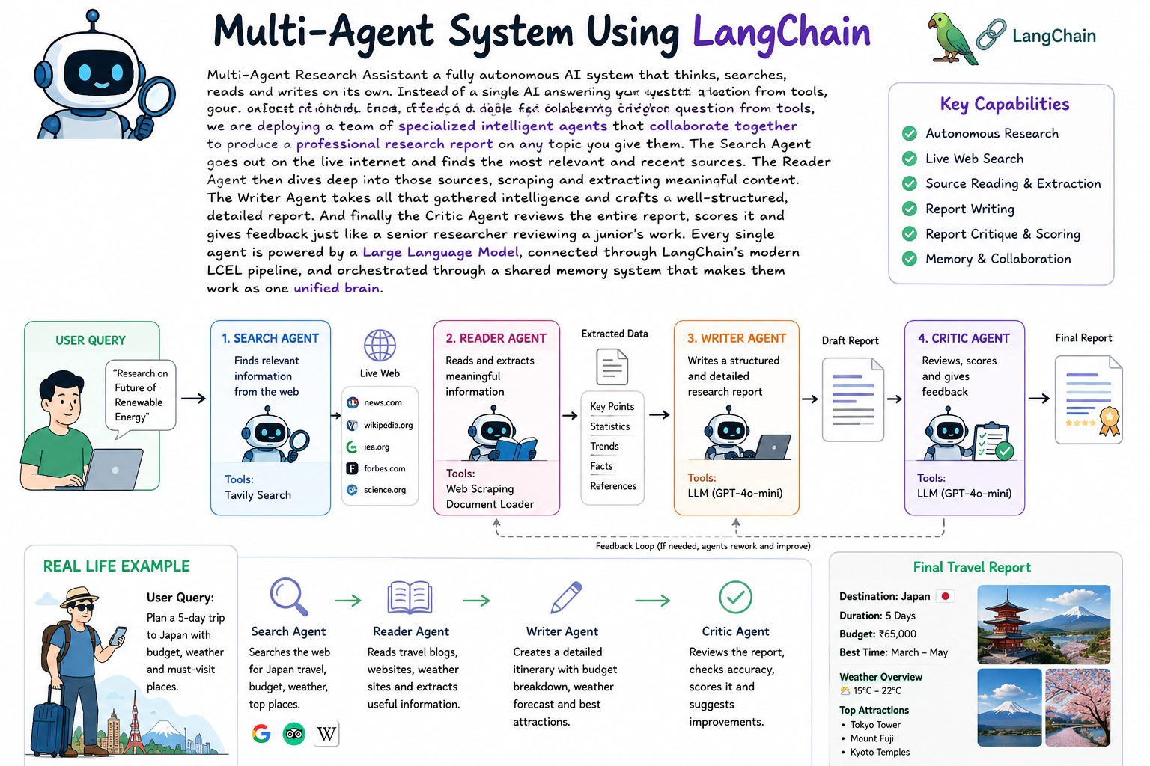

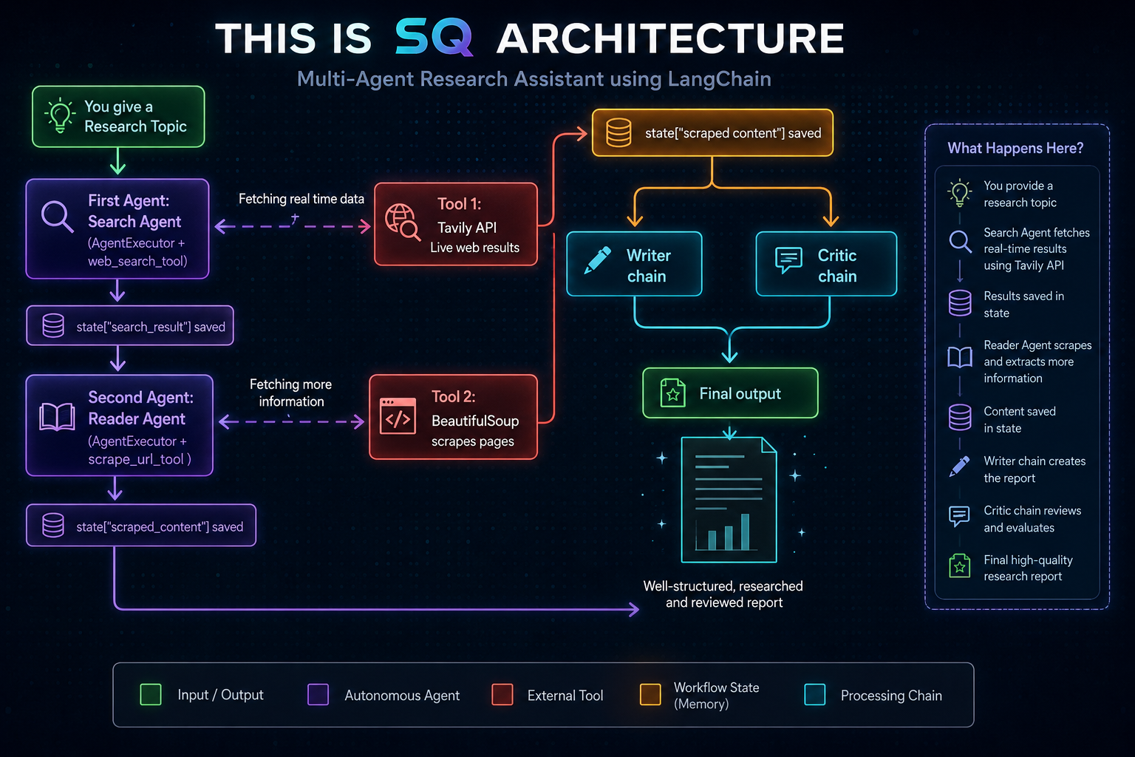

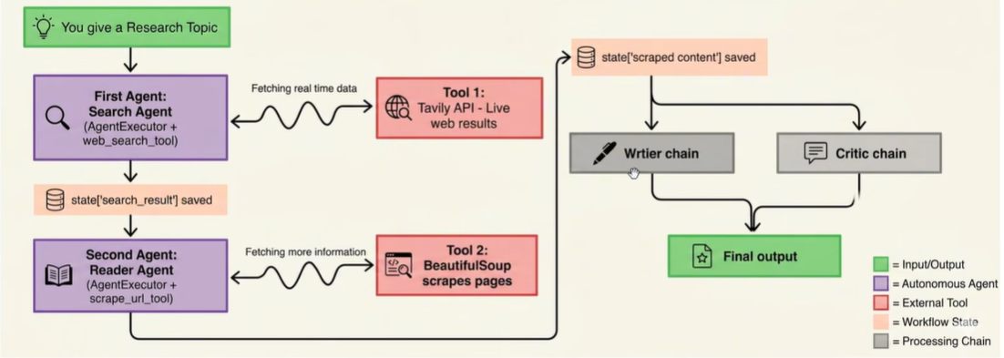

Steps:
1. Environment Setup
2. Create tools
3. Create Agents
4. Create Pipeline
5. Run & Test

